SmartRetail Vision: AI-Powered Autonomous Inventory Monitoring and Shelf Analytics
Git & Docker Technical Assignment Report
1. Problem Analysis
1.1 Problem Statement
Retail stores face financial losses due to stockouts, overstocking, incorrect shelf placement, and delayed inventory updates. Manual inventory audits are time-consuming, labor-intensive, and may not provide real-time information about product availability.
SmartRetail Vision is an AI-powered shelf analytics system designed to continuously monitor retail shelves using computer vision and deep learning. The system detects missing, misplaced, or unavailable products and provides inventory insights and replenishment alerts.
1.2 Objectives
- Develop an AI-powered computer vision system for real-time shelf monitoring.
- Detect stock shortages, misplaced items, and empty shelves automatically.
- Analyze shelf images using deep learning object detection models.
- Generate real-time inventory replenishment alerts.
- Provide analytics on product visibility and shelf utilization.
- Predict inventory demand using historical sales and shelf data.
- Integrate with existing retail inventory management systems.
- Improve operational efficiency through automated inventory tracking.
1.3 Functional Requirements
- User authentication and access management.
- Capture and process shelf images.
- Detect products using AI-based object detection.
- Identify missing and misplaced products.
- Detect empty shelf spaces.
- Monitor inventory anomalies.
- Generate replenishment alerts.
- Display shelf analytics through a dashboard.
- Analyze historical inventory and sales data.
- Predict future product demand.
- Generate reports and analytics.
- Support integration with inventory management systems.
1.4 Expected Outcomes
- Real-time visibility of shelf inventory status.
- Reduced stockouts and inventory inaccuracies.
- Faster inventory replenishment.
- Improved product availability.
- Reduced manual inspection effort.
- Better customer satisfaction.
- Improved merchandising decisions.
- A scalable solution for supermarkets, malls, and retail chains.

2. Project Structure Design
The SmartRetail Vision repository can be organized as follows:
SmartRetail-Vision/
│
├── frontend/
│ ├── src/
│ ├── public/
│ ├── package.json
│ └── Dockerfile
│
├── backend/
│ ├── app/
│ ├── requirements.txt
│ └── Dockerfile
│
├── ai-model/
│ ├── models/
│ ├── dataset/
│ ├── training/
│ └── inference/
│
├── database/
│ └── init.sql
│
├── tests/
│ ├── frontend/
│ ├── backend/
│ └── ai/
│
├── docker/
│ └── docker-compose.yml
│
├── docs/
│ ├── architecture/
│ └── screenshots/
│
├── .gitignore
├── README.md
└── docker-compose.yml
Purpose of Major Folders and Files
Folder/File | Purpose
frontend/ | Contains the user dashboard and interface
backend/ | Handles APIs and application logic
ai-model/ | Contains AI model, training, and inference components
database/ | Contains database initialization scripts
tests/ | Stores application test cases
docker/ | Contains Docker-related configuration
docs/ | Stores diagrams and project documentation
.gitignore | Specifies files that Git should ignore
README.md | Provides project information and setup instructions
docker-compose.yml | Defines and manages multiple application containers

Web dashboard:
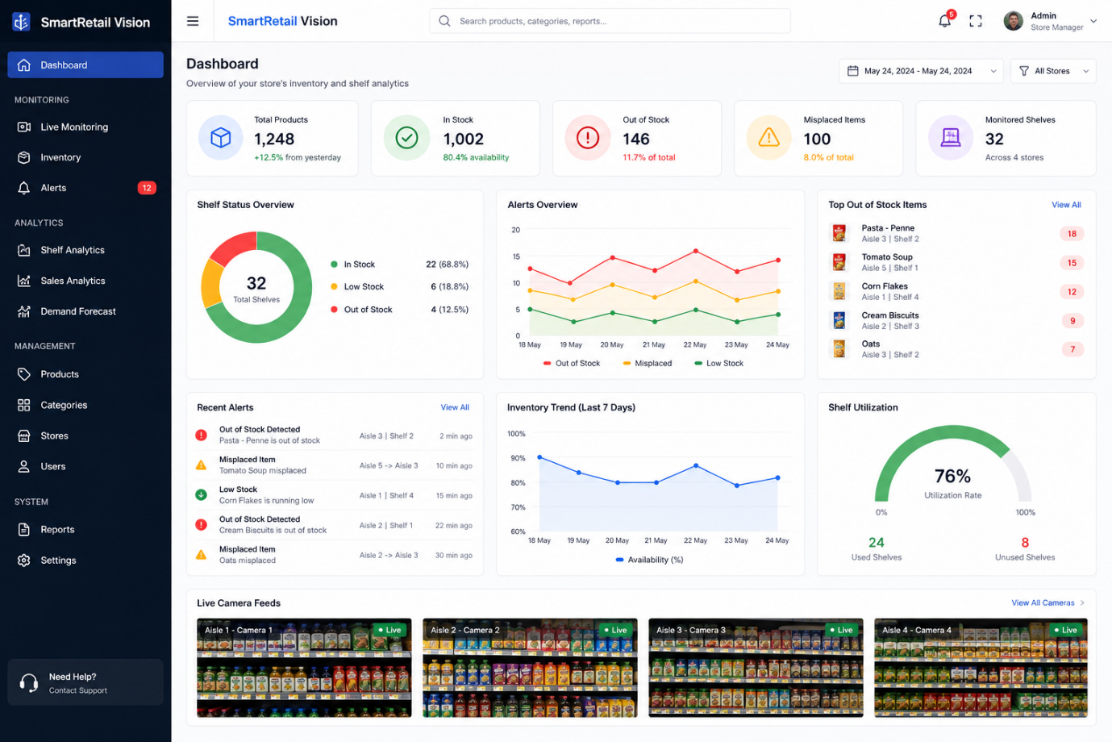
3. Git Repository Initialization
Git is used to maintain the source code, track modifications, support branching, and enable collaborative development.
Git Initialization Commands
mkdir SmartRetail-Vision
cd SmartRetail-Vision

git init

git add .
git commit -m "Initial project setup"

git branch -M main

git remote add origin <repository-url>

git push -u origin main
Important Git Files
.git/
Created automatically by git init. It contains Git's internal repository information, including commits, branches, and configuration.
.gitignore
Specifies files and folders that should not be tracked, such as environment files, dependencies, generated files, and temporary data.
README.md
Contains project description, installation instructions, usage information, and development guidelines.

Github Repository
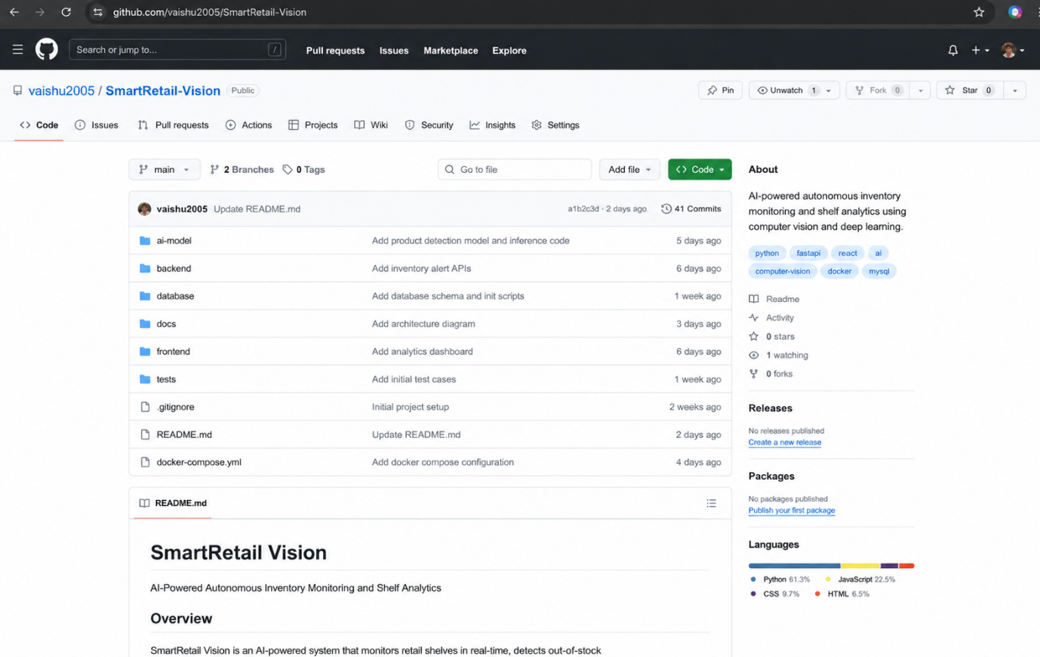
4. Git Branching Strategy
The project uses a structured branching strategy:
main
│
develop
/ | \
/ | \
feature/ feature/ feature/
frontend ai-model backend
\ | /
\ | /
develop
│
release
│
main
│
hotfix
Branches
Main:
Contains stable and production-ready versions.
Develop:
Contains integrated development work before release.
Feature:
Used for implementing individual features such as AI detection, dashboard development, and alert management.
Release:
Used to prepare and test a stable version before deployment.
Hotfix:
Used to quickly correct critical problems in the main branch.
Justification
This branching model is appropriate because SmartRetail Vision contains multiple components that can be developed independently. Developers can work on frontend, backend, and AI features without directly affecting the stable version.

5. Version Control Workflow
The development workflow is:
Create Feature Branch
↓
Develop Feature
↓
git add
↓
git commit
↓
Push Feature Branch
↓
Code Review
↓
Merge into Develop
↓
Testing
↓
Release
↓
Merge into Main
Important Git Commands
git status
git add .
git commit -m "Add shelf detection module"

git branch feature/shelf-detection
git checkout feature/shelf-detection

git push origin feature/shelf-detection

git checkout develop
git merge feature/shelf-detection

git pull origin develop
git push origin develop
Conflict Resolution
If a merge conflict occurs:
git status
The conflicting file is edited manually and the correct changes are retained.
git add .
git commit -m "Resolve merge conflict"
The resolved branch can then be merged and synchronized with the remote repository.
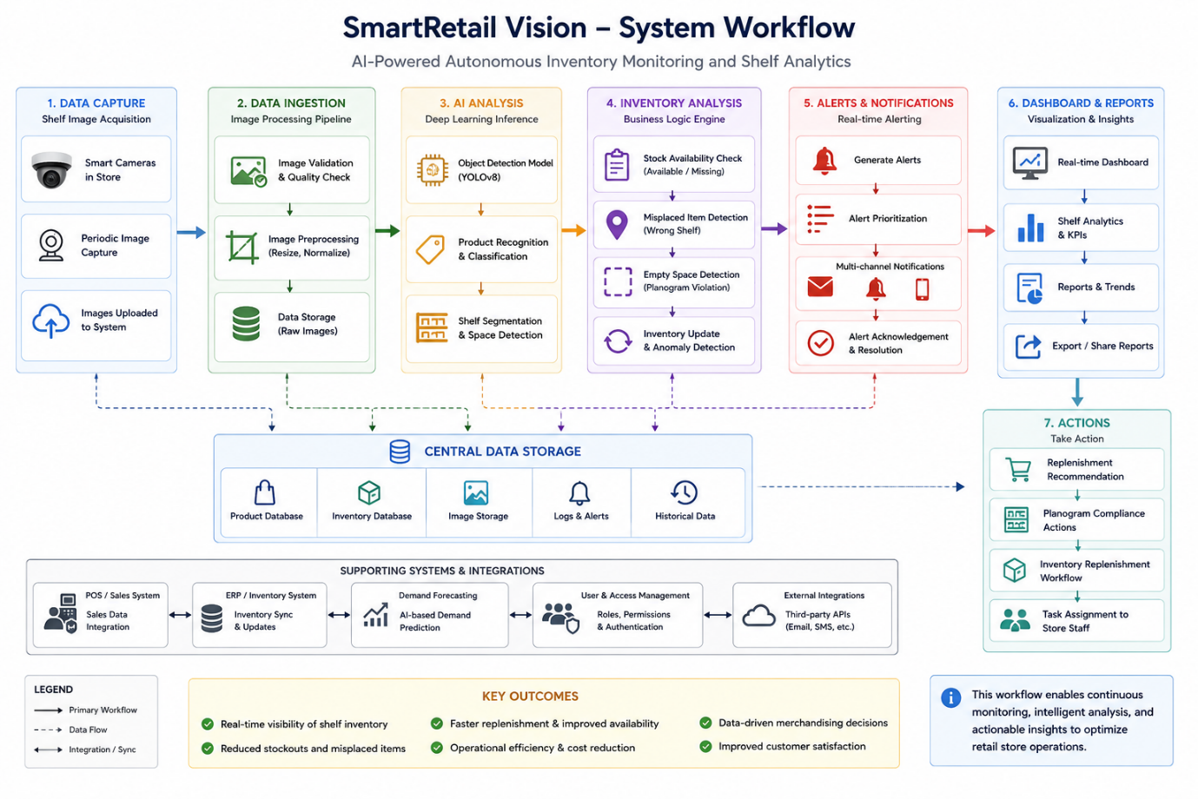

6. Commit History Analysis
Meaningful and descriptive commit messages should be used to maintain a clear project history.
Example Commit History
Initial project setup
Add frontend dashboard
Add backend API
Add AI product detection module
Add database configuration
Add inventory alert module
Add Dockerfile
Add Docker Compose configuration
Fix product detection API
Update dashboard analytics
Fix Docker networking issue
Prepare release version
Good commit messages make it easier to understand what changed and help developers identify and troubleshoot previous modifications.
Example:
git log --oneline
Expected output:
a83f2c1 Add Docker Compose configuration
7d91a20 Add inventory alert module
4bc812e Add AI product detection
2fa731d Add backend API
1c92aa0 Initial project setup

7. Docker Environment Design
Docker is suitable for SmartRetail Vision because the project contains multiple components that require consistent environments.
Components Requiring Containerization
- Frontend application
- Backend API
- AI inference service
- Database
Docker Architecture
SmartRetail Vision
│
Docker Compose
│
┌──────────────────┼──────────────────┐
│ │ │
Frontend Backend AI Service
Container Container Container
│ │ │
└──────────────────┼──────────────────┘
│
Database
Container
Benefits of Docker
- Consistent development environment.
- Easier deployment.
- Dependency isolation.
- Portability across systems.
- Easy service management.
- Simplified application scaling.

8. Dockerfile Development
A Dockerfile defines the instructions required to create a container image.
Backend Dockerfile
FROM python:3.11-slim

WORKDIR /app

COPY requirements.txt .

RUN pip install --no-cache-dir -r requirements.txt

COPY . .

EXPOSE 8000

CMD ["python", "app.py"]
Explanation
FROM – Specifies the base Python image.
WORKDIR – Sets the working directory inside the container.
COPY – Copies project files into the container.
RUN – Installs the required dependencies.
EXPOSE – Indicates the application port.
CMD – Defines the command executed when the container starts.

9. Docker Compose Design
Docker Compose is used to manage multiple containers as a single application.
docker-compose.yml
version: "3.9"

services:

frontend:
build: ./frontend
ports:
- "3000:3000"
depends_on:
- backend

backend:
build: ./backend
ports:
- "8000:8000"
depends_on:
- database
- ai-model

ai-model:
build: ./ai-model
ports:
- "5000:5000"

database:
image: mysql:8
environment:
MYSQL_ROOT_PASSWORD: root
MYSQL_DATABASE: smartretail
ports:
- "3306:3306"
volumes:
- db_data:/var/lib/mysql

volumes:
db_data:
Services
Frontend: Provides the user interface.
Backend: Handles APIs, application logic, and communication between services.
AI Model: Processes shelf images and performs product detection.
Database: Stores inventory and analytics data.
Networking
Docker Compose automatically creates a network that allows containers to communicate using service names.
Volumes
The database volume maintains data even if the database container is restarted or recreated.
Dependencies
depends_on defines the startup dependency between services.

10. Container Deployment and Testing
The complete application can be built and started using:
docker compose build
docker compose up
To run containers in the background:
docker compose up -d
To check running containers:
docker ps
To view logs:
docker compose logs
To stop the application:
docker compose down
Testing Procedure
- Build all Docker images.
- Start all services using Docker Compose.
- Verify that all containers are running.
- Open the frontend dashboard.
- Test communication between frontend and backend.
- Upload or provide a shelf image to the AI service.
- Verify product detection results.
- Verify inventory alerts.
- Verify database storage.
- Check application logs for errors.
Evidence to Include
The following screenshots should be added to the report:
- Git repository initialization.
- Git branches.
- Git commit history.
- Git merge operation.
- Docker image build.
- docker compose up.
- docker ps.
- Application dashboard.
- AI product detection output.
- Docker logs.

11. Benefits of Git and Docker
Git Benefits
Collaboration: Multiple developers can work on different features.
Version Management: Changes are tracked through commits.
Branching: Features can be developed independently.
Rollback: Previous versions can be restored when required.
Maintainability: A structured history makes the project easier to manage.
Docker Benefits
Portability: The application can run consistently on different systems.
Deployment: Services can be deployed using predefined configurations.
Isolation: Each service operates within its own environment.
Scalability: Individual services can be scaled according to requirements.
Consistency: Development and deployment environments remain consistent.

12. Challenges and Improvements
Challenges
- Training and configuring the AI object detection model.
- Obtaining suitable shelf images and datasets.
- Detecting products under different lighting conditions.
- Identifying misplaced products accurately.
- Managing communication between multiple Docker containers.
- Handling dependencies between frontend, backend, AI, and database services.
- Resolving Git merge conflicts during collaborative development.
- Maintaining real-time inventory information.
Future Enhancements
- Improve AI detection accuracy using larger datasets.
- Add real-time camera-based shelf monitoring.
- Implement advanced demand prediction.
- Add automated stock replenishment recommendations.
- Integrate with real retail inventory systems.
- Add cloud deployment.
- Implement role-based access control.
- Add advanced sales and merchandising analytics.
- Support multiple stores and branches.
- Introduce automated CI/CD using Git and Docker.

Conclusion
SmartRetail Vision provides an AI-powered approach to autonomous inventory monitoring and shelf analytics. The system uses computer vision, deep learning, inventory management, and analytics to identify shelf-level problems and support better replenishment decisions.
Git provides version control, collaboration, branching, and project history management, while Docker provides a consistent and portable environment for deploying the application's different components. Together, Git and Docker improve the project's maintainability, portability, collaboration, and deployment process.
The proposed architecture provides a foundation for developing a scalable smart retail solution capable of reducing manual inventory inspection, improving product availability, and supporting data-driven retail management.

